The Category and Item setup for progress payments is the same as the category and item setup that is required for deposits. Additional setup for progress payments is the creation of Payment Types. Payment types are created via Lookups > Progress Payment Types.

To get started with Progress Payments create a purchase order then select Setup Progress Payments from the Tools menu.
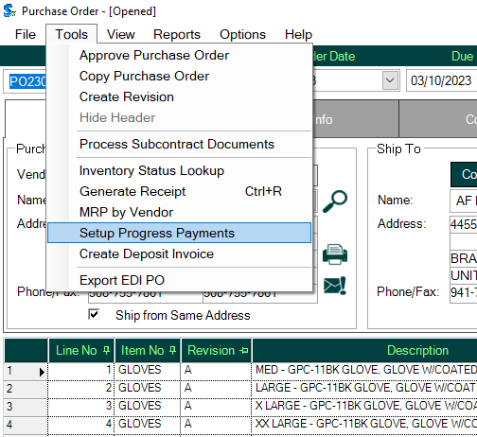
Set up the payment schedule by assigning payment types, payment sequence and payment due dates.
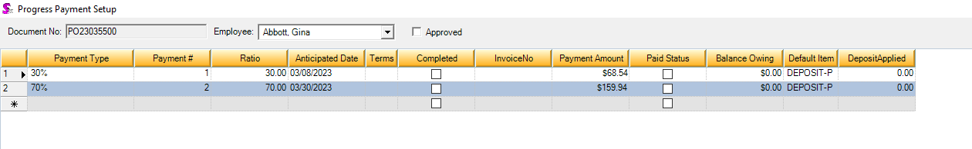
The progress payment schedule must be approved to generate AP Invoices.
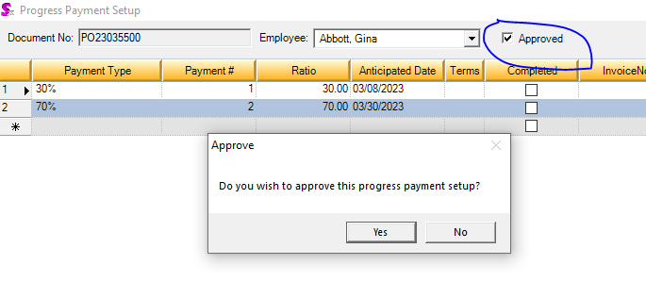
When payment time comes, go to Utilities > Day End Processing > Tools > Generate Recurring Transaction.
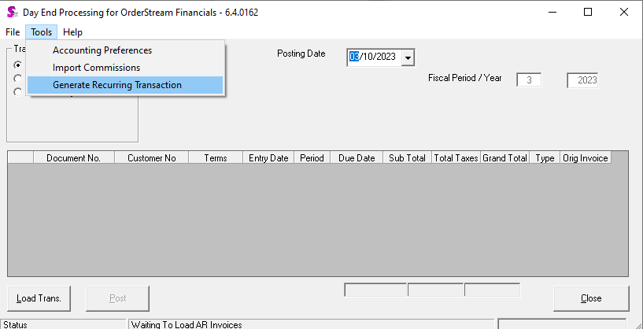
Click on the Progress Payments tab. Adjust the “Show Due Within” date filter as necessary. Include the purchase order then click Generate.
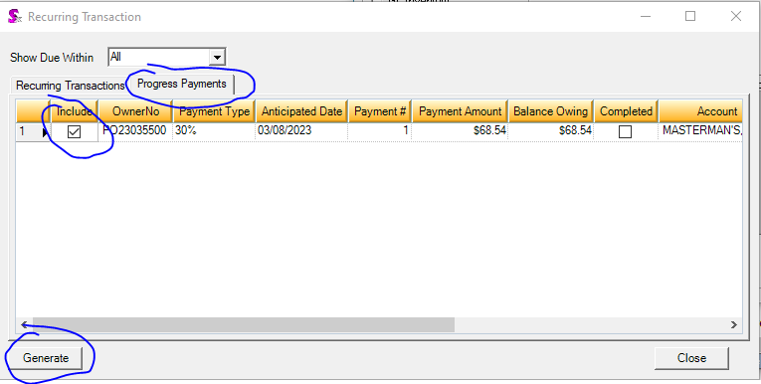
The Generate Progress Payment screen is displayed… you will notice it looks very similar to the Deposit Invoice generation screen. Click Generate.
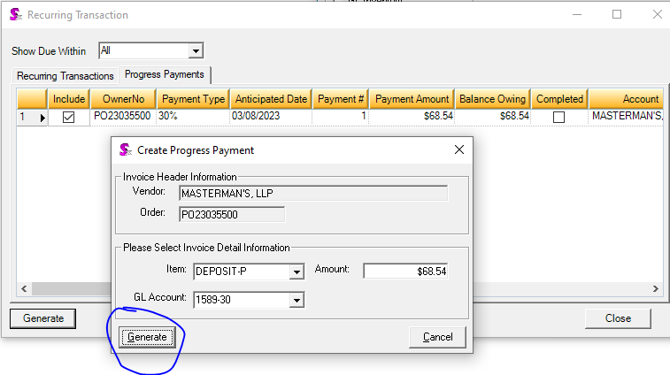
Click OK to proceed.
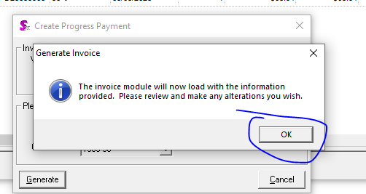
The Vendor Invoice Module will load. The item you have setup to be used for progress payments will be loaded on the Miscellaneous tab (just as it was for Deposit Invoices).

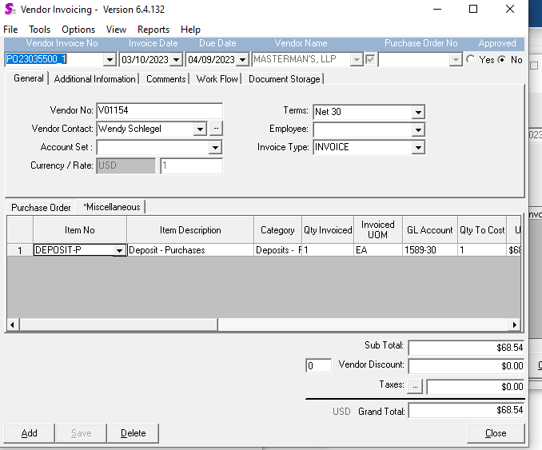
Approve the invoice and post to accounting.
To process the next prepayment, repeat the generation process starting from Utilities > Day End Processing > Tools > Generate Recurring Transaction.
Once the purchase order is received and invoiced, the prepayments will be deducted from the balance owing with negative lines on the Miscellaneous tab (again, the same concept as deposits) leaving any outstanding amount as the balance remaining to be paid.

